**Assignment Tracker Documentation**

This documentation will serve as instruction for using the Assignment Tracker program. It is assumed that users will have basic python knowledge and command line familiarity as well as basic understanding of the version control system Git and use of Github (for the code base).

**Getting Started**

In order to start using the assignment tracker users will need to have Python Version 3.9+ installed on their system. The github repository hosting the code base can be found at: [m-barneto/CSC289-Capstone (github.com)](https://github.com/m-barneto/CSC289-Capstone). Users should read the README located at the bottom of the page for initial setup/installation.

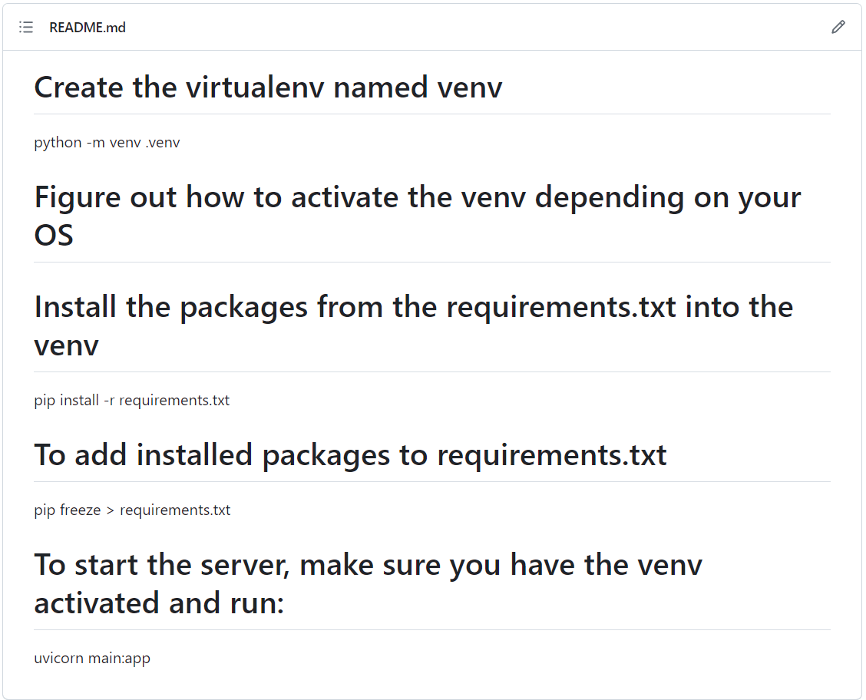

**Using the Assignment Tracker**

When users first start up the Uvicorn server by running “uvicorn main:app” they will be greeted with the Main Menu page of the assignment tracker. Here users can view some basic instructions for using the application as well as see a number of menu buttons to navigate to different pages.

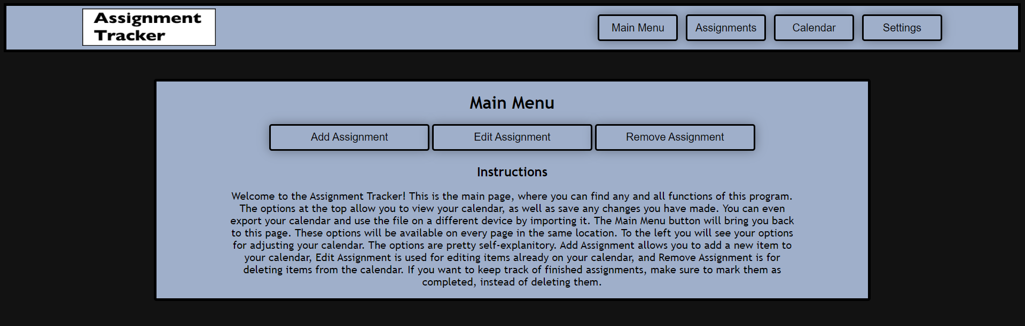

From the main menu, and subsequent pages, users can click on the labeled buttons to navigate between the different functions of the assignment tracker.

Users can click the Calendar button to get a view of their calendar as it currently exists. If users are not on the main menu page they can click *Main Menu* to return to the main menu page.  
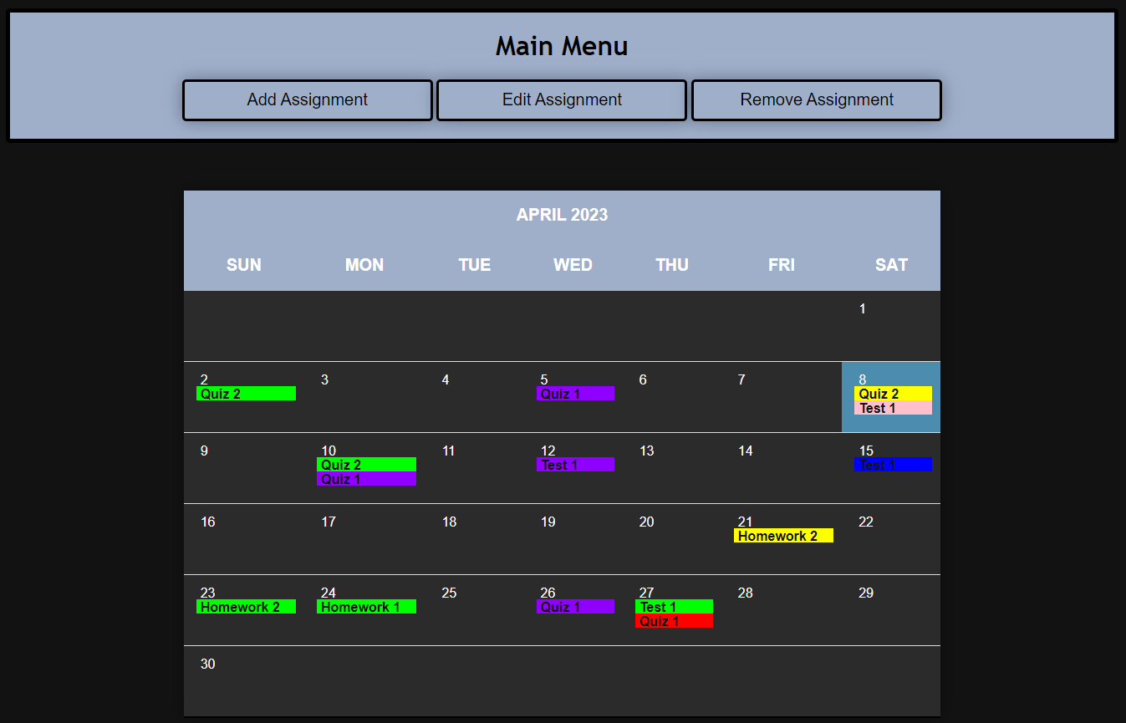

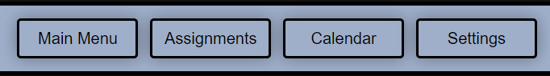

From the Add Assignment page, users can add in a new assignment to the calendar by filling in some basic data such as Assignment Name, Class, Due Date, and Grade Weight. Once a user has filled in this information they can click the submit button to have it added to the calendar.

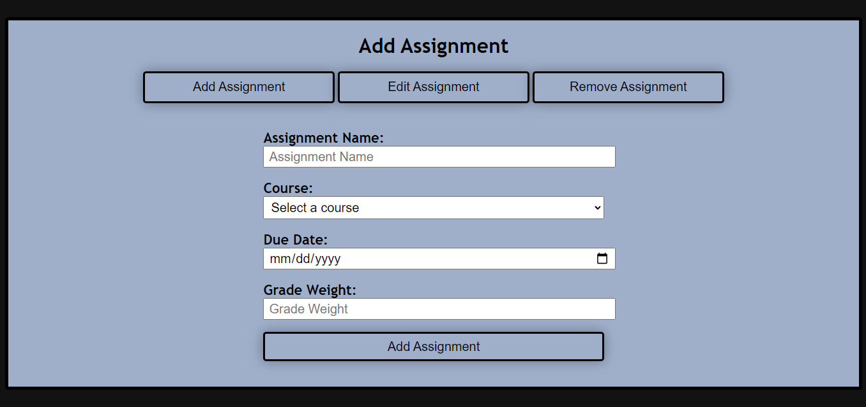

From the Edit Assignment page, users can edit already existing assignments to update things like the Assignment Name, Class, Due Date, and Grade Weight.

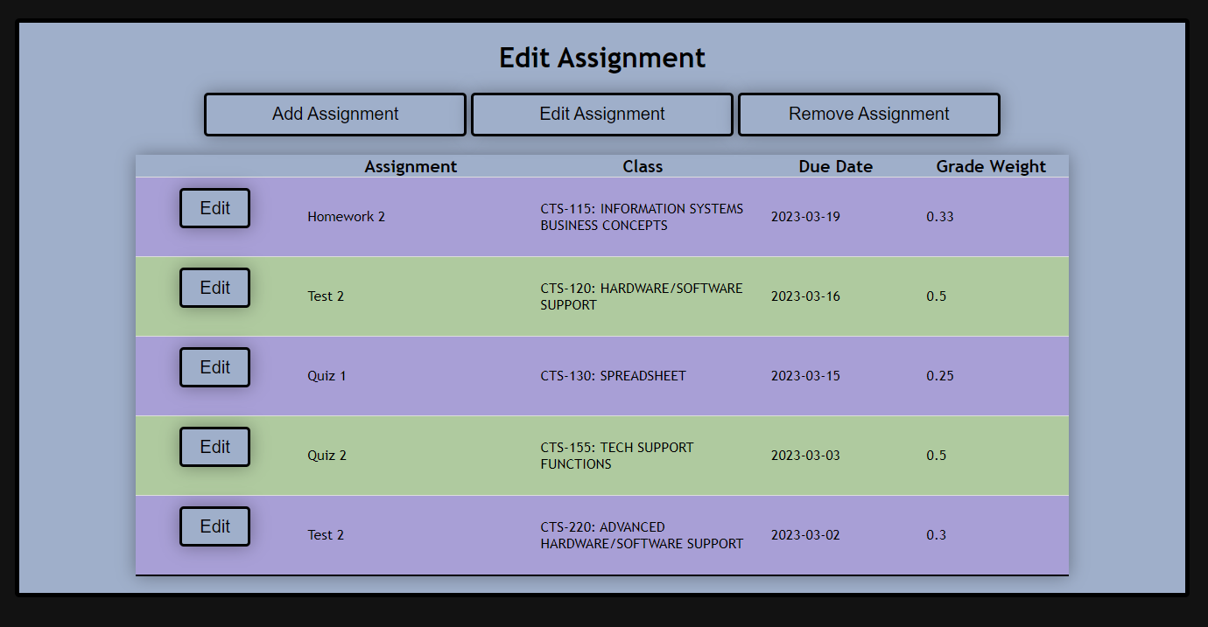

From the Remove Assignment page, users can select assignments that they wish to be removed from the calendar.

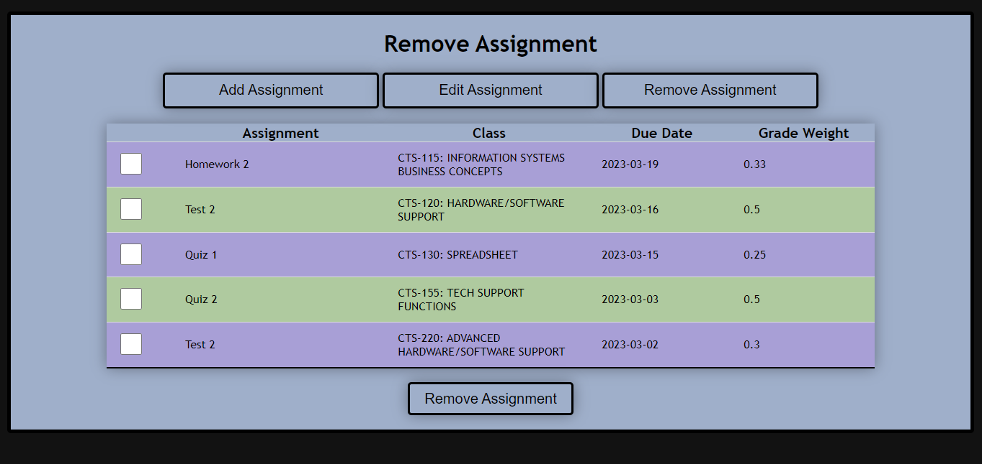

From the Settings Page users are able to import url links to an .ics file. They can also import and export the database (.db file) for transfer to another machine, as well as manually add in and remove courses from the database.

